New Microsoft Azure AD Multifactor Setup

FBM uses Microsoft Azure AD for Multifactor authentication (MFA). FBM requires the Authenticator app as the approved method for MFA, which is an available app for iPhone and Android.

NOTE - Your phone will need to have a lock screen passcode or biometric security (fingerprint or face ID) setup in order for the Microsoft Authenticator App to work properly.

Performing the initial validation of your Azure AD Account
Azure AD is Microsoft’s global authentication system, and it is already configured for your @fbmsales.com credentials. To start the setup process, browse to the URL below:

http://aka.ms/mfasetup

After signing in with your FBM email address and password, you will be notified that more information is required. Click Next.

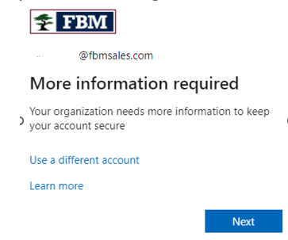

The default authentication method is to use the free Microsoft Authenticator App. Download the app or if you already have it installed on your mobile device, click Next.

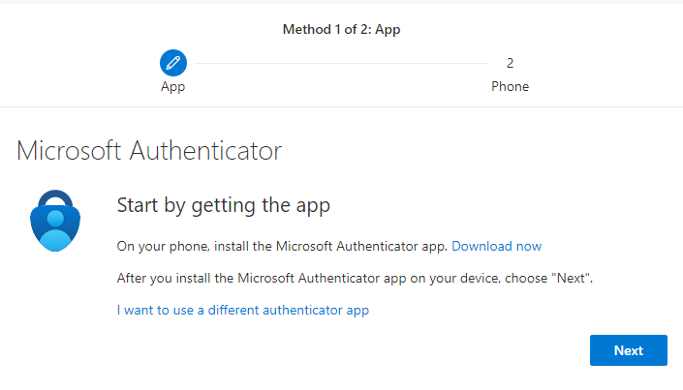

Open the authenticator app on your phone and tap on the plus sign “+” at the top right to add account.


Select Work or school account and then select Scan QR code.
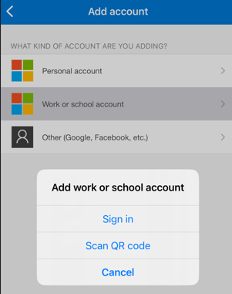

Go back to the computer screen and then click Next

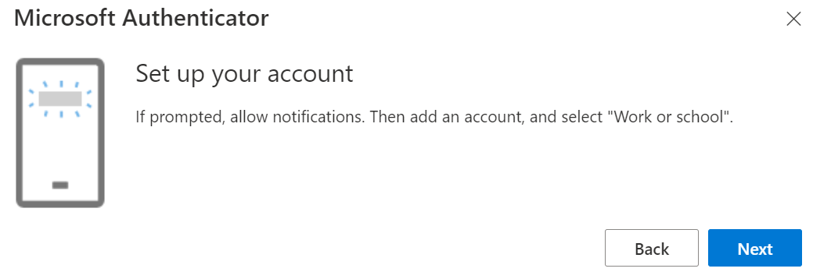

The website should give you a QR code to scan with your phone. (NOT the QR code in this document in the screenshot below). Then click Next

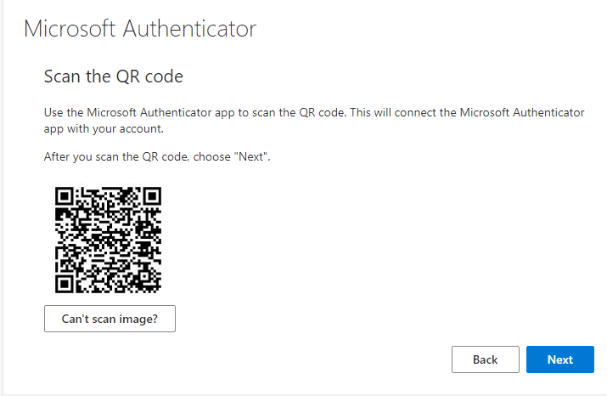

NOTE - If you are not prompted to scan a QR code from the app on your mobile phone, try going into the app again and clicking on Verified ID’s in the bottom right, then choose Scan QR code.
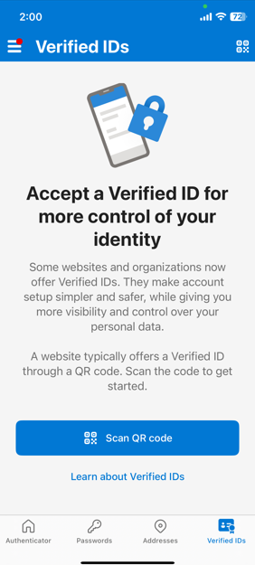

After scanning the QR code on your computer screen, you will be prompted to try it out. Go the Microsoft Authenticator app on your phone to test it out by entering the 2 digit number given. Do NOT use the 2 digit number in the example screenshot below; you should receive a unique number on your screen to enter into the app when prompted. After entering the 2 digit code given, you can click Next and you will receive notification that you are all set.

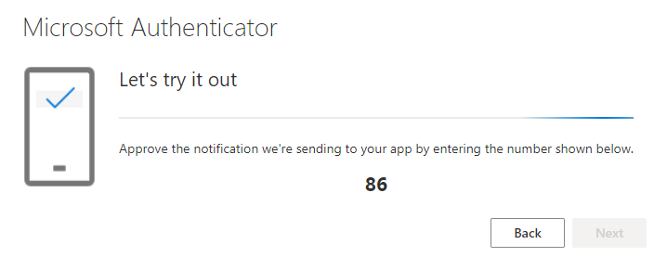

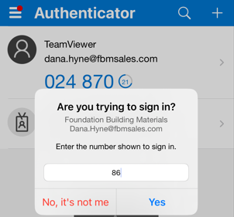

The Microsoft Authenticator notification has been approved. Click Next.
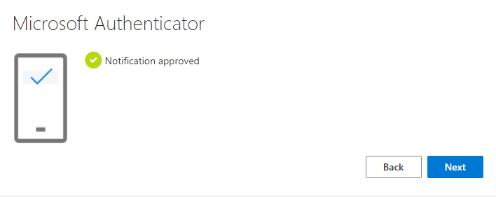

Your MFA has been successfully added to your account. Click Done.
