Forgot or Change Your FBM Password

If you know your password and are trying to sign into an FBM application and receive a notification that your account is locked after too many attempts, please wait 30 minutes for the lock to come off and try again. Make sure your Number lock key is on and that your Caps lock key is off. If you are still unable to sign-in, then you may need to change your password.

Password expiration notification emails will come from SQLNotifications@fbmsales.com and are distributed 30 days prior to expiration and will continue to be sent each week leading up to expiration.

Forgot your FBM Password

If you have forgotten your FBM Password, you can access the self service password reset portal at the computer’s Windows login screen by clicking on the Reset Password link under the password entry field box.

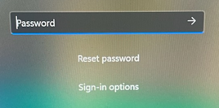

If you do not see the Reset Password option, click on Sign-in options, then click on the Key icon. You will then see the Reset Password option

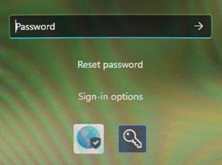

You can also browse to the URL: https://myaccount.microsoft.com or https://myapps.fbmsales.com to access the Self Reset Password Portal from a web browser.

When the portal screen opens, enter your FBM email address and click on Forgot my password.

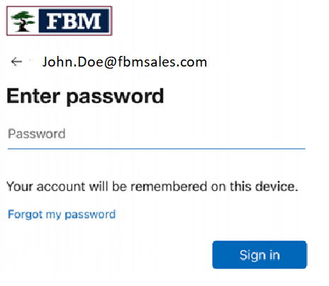

You will be asked to verify your identity; follow the instructions as directed to reset your password.

New passwords must meet the requirements below:
- Password must be at least 15 characters long.
- Password cannot contain your name or your username.
- Password cannot contain the company name, seasons or months of the year.
- Password must contain at least 3 of the 4 complexity requirements:
  - Lower case letter
  - Upper case letter
  - Number
  - Special character (!, @, #, $, etc.)
- You cannot use any of your last passwords.

If you are unable to reset your password in this manner, contact FBM Support at 616-724-2730 or email supportcenter@fbmsales.com. You will be required to provide your branch location and manager’s name for verification. If calling FBM Support, please do so from a Ring Central phone or your company cell phone.

Change your password

If you wish to change your FBM Password, browse to the URL: https://myaccount.microsoft.com or https://myapps.fbmsales.com and enter your FBM email address and current password.

You may be asked to verify your identity; follow the instructions as directed.

Once you are fully logged into your account, click on the Change Password link in the Password section.

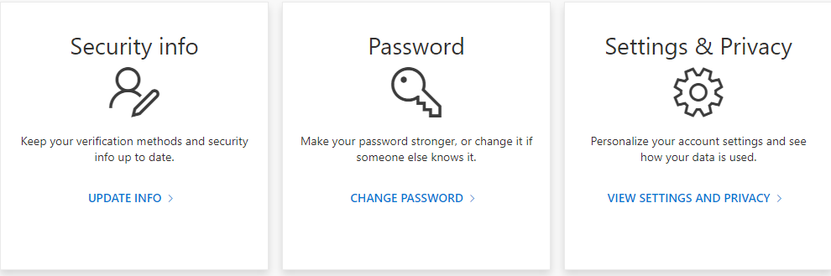

Enter your new password in the New password field and again in the Confirm new password field; these two field entries must match and follow the password requirements below. Click Submit when done.

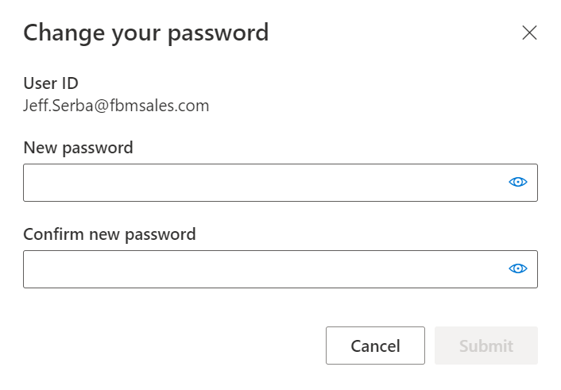

After clicking Submit, make sure you see that your password has been successfully changed, then click Done.

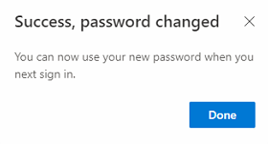

New passwords must meet the requirements below:
- Password must be at least 15 characters long.
- Password cannot contain your name or your username.
- Password cannot contain the company name, seasons or months of the year.
- Password must contain at least 3 of the 4 complexity requirements:
  - Lower case letter
  - Upper case letter
  - Number
  - Special character (!, @, #, $, etc.)
- You cannot use any of your previous passwords.

