Creating and Managing Rules in Outlook

Rules can be created in Microsoft Outlook to automatically handle certain incoming and outgoing emails based on conditions you have specified. There are a couple different ways to create and manage rules in Outlook. An easy way to create a rule based on a certain email in your Inbox, is to highlight the email and on the Header in Outlook click on Move, then click on Rules and choose Create Rule:

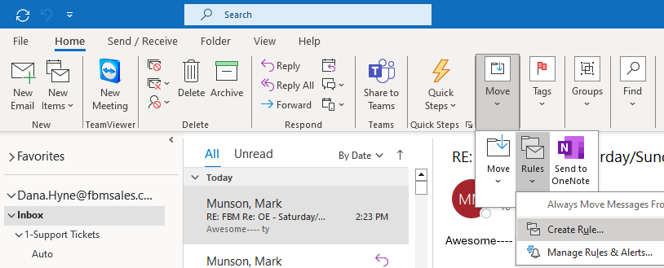

After clicking on “Create Rule”, a window will pop up with check boxes allowing you to choose to take the email from the sender and with a certain subject word(s), and forward those emails to a folder or another FBM email address. The example below is taking an emailed SX root report from sender “root” and with the word “SOX” in the subject line, then forwarding the email to another FBM employee’s email address. REMEMBER: FBM emails should NEVER be forwarded to NON-FBM employees. After checking the desired boxes, click on “Advanced Options”:

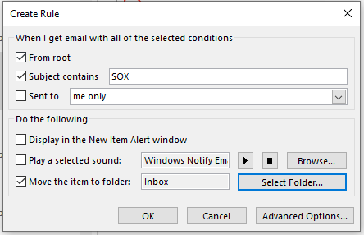
The next window that pops up will allow you to choose more options for your rule. Click “Next” to get to the next window pop up. This window will allow you to choose to move the email(s) to a folder or forward it to another FBM employee (among many other options). In the example of forwarding the SOX root report to another FBM email address, you would check the box for “forward it to people or public group”. After checking that box, you’ll have to click on the blue word link “people or public group” so you can enter the FBM email address to forward that email to:

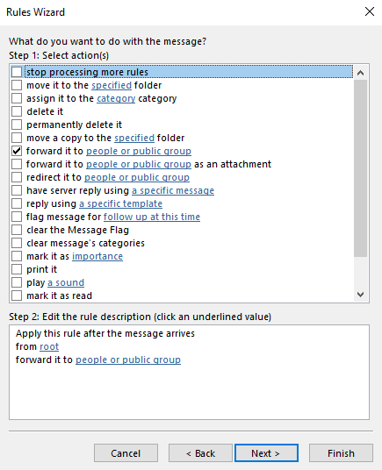

After clicking on the blue word link “people or public group”, the Outlook address book will pull up for you to choose the FBM email(s) to forward these emails to. After choosing the email destinations, click “Finish” to complete the rule.

If you want to change the rule or delete the rule, click back on the “Rule” option on the toolbar and choose “Manage Rules and Alerts”.

