Printer Installer

This document will walk you through how to install network printers on your computer.

Go to the Start Menu and choose All at the top right.

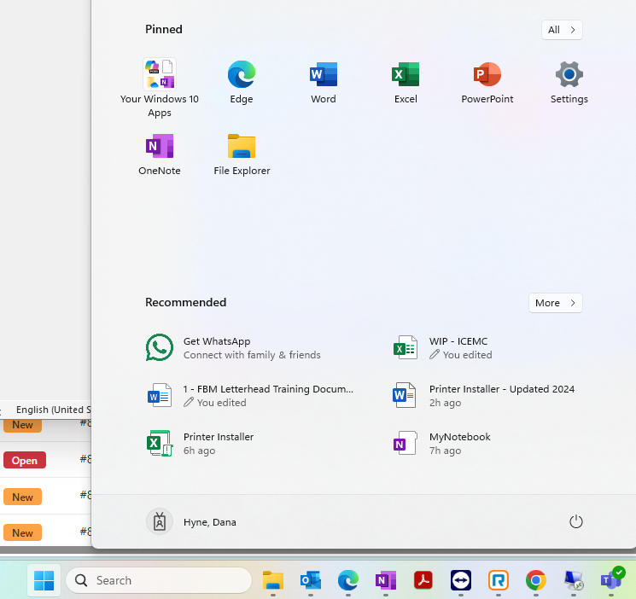

Find the FBM Utilities folder and click on it to expand the folder, then click on Printer Installer to open the Excel spreadsheet.

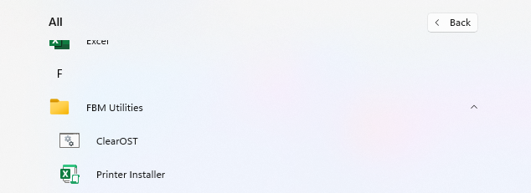

If it is your first time ever opening the Printer Installer spreadsheet, there may be a yellow box that says “Enable Content” at the top, above all the columns. If this banner is there, click on Enable Content and then click “Yes” on the box that pops up asking if you want to make this file a Trusted Document.
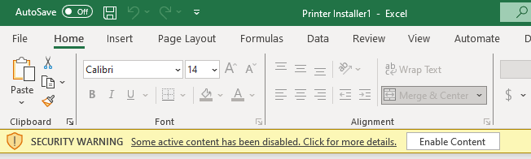

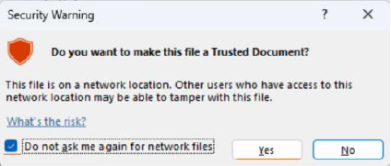

Scroll down to the bottom of the spreadsheet and click on the orange button that says
“Press This Button to See a List of Printers for a Location”.



A box will appear asking for the branch number of the printer. This will be the branch number with no leading zeros. Enter your branch number and click OK.

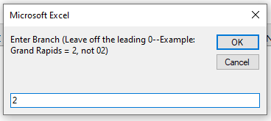
After clicking OK, you will be shown a list of printers for the location you entered. To download the printer, simply click on the blue hyperlink.

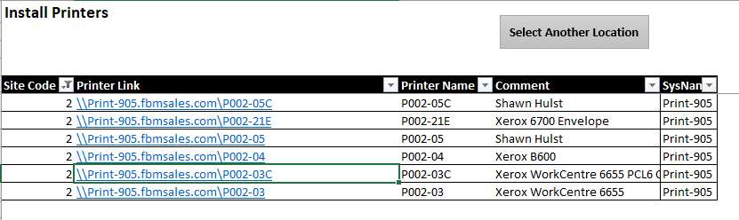

A box will appear asking if you want to install this printer, click “Yes”.
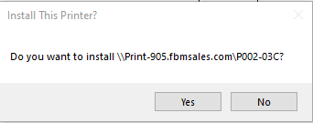

You can continue installing more printers by clicking on the appropriate blue hyperlink, as needed. Once you are finished you can close the Printer Installer spreadsheet. Do not save the file.

To set your default printer, go to your Search bar and type “Printers”, then click on the Printers and Scanners settings to open.
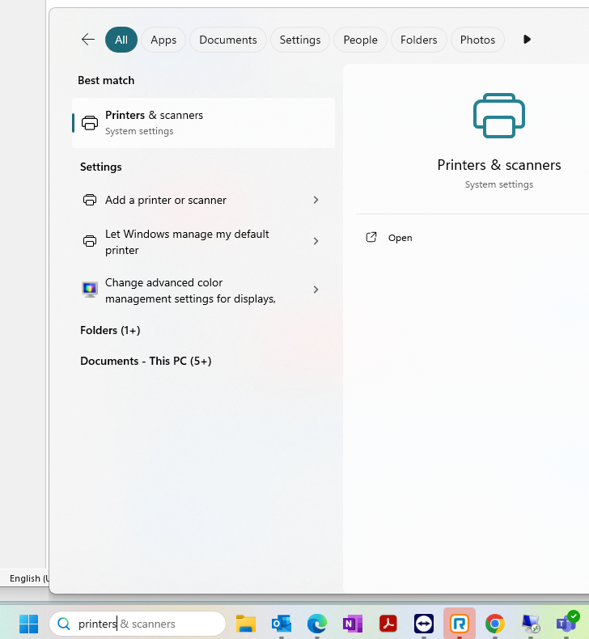

Under Printer Preferences, toggle off “Let Windows manage my default printer” then select the printer you want to set as the default.

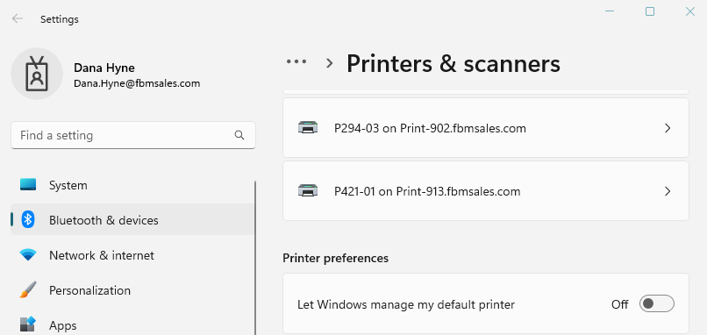

Click on Set as default option at the top.
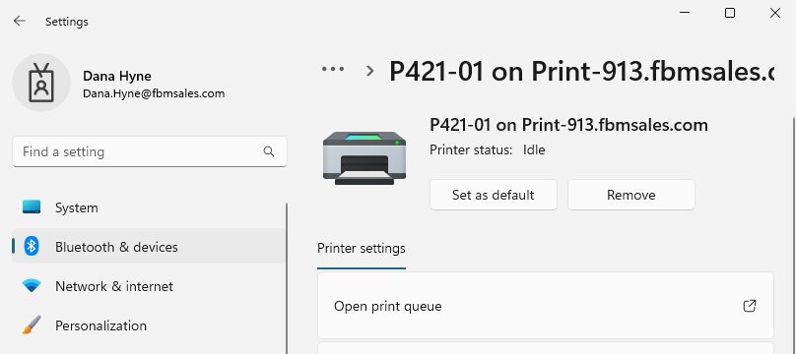

To delete the printer, click on Remove.

