Setting an Automatic Reply on Another User’s Mailbox

The following instructions will help you set an automatic reply on a mailbox that you have been given access to from the IT Team (usually in the case of a terminated employee).

- Open a web browser and navigate to https://outlook.office.com/owa/ (or click link) and sign in with your FBM email address and password.
- Once in your mailbox, click on your initials in the top right corner and then select “Open another mailbox…”
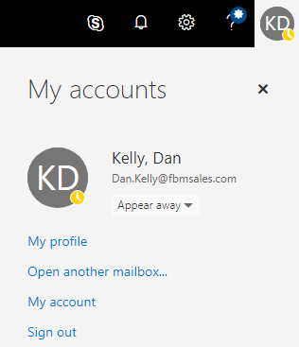

- The “Open another mailbox” dialogue box will appear. Here, you can type in the first or last name of the employee and then select them by clicking on their name. Once the employee is selected, click Open:
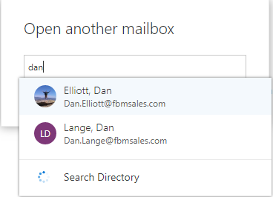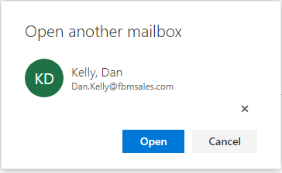

- The selected employee’s mailbox will then open in a new tab in the web browser. Once in the mailbox, click the gear icon in the top-right corner; this is the Settings button. In the Settings section, select “Automatic Replies”:
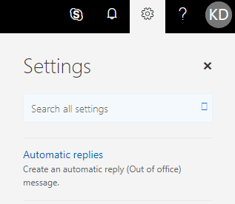

- Now you can set up Automatic replies for the employee’s account.

