Managing Junk Email Folder

If you find that emails you would like to receive are not showing in your Inbox, they may be in your Junk Email folder. Below shows where to find the Junk Email folder in Outlook and in Outlook Web App.

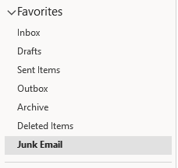
Outlook

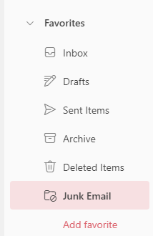
Outlook Web App

If you are receiving an email from a sender that you would like to block, right-click the email in your Inbox and select the options highlighted below. This will move the selected email and any future emails from that sender to the Junk Email folder.

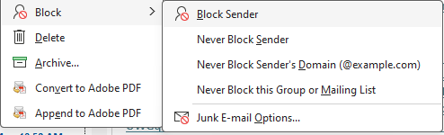
Outlook

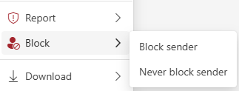
Outlook Web App

If you have located an email you want to retrieve in the Junk Email folder, right-click it to see the menu shown below and Go to Report. To flag the sender as “Not Junk” so their emails go to your Inbox instead, select the options shown below.

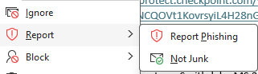
Outlook

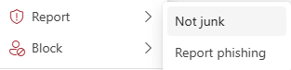
Outlook Web App

The following prompt will appear. Select “Report” to confirm. The email will go to your Inbox and the sender will be marked as trustworthy for future emails.

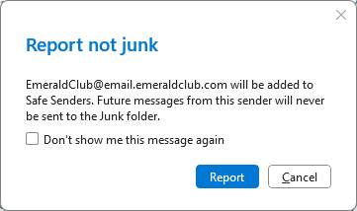
Outlook

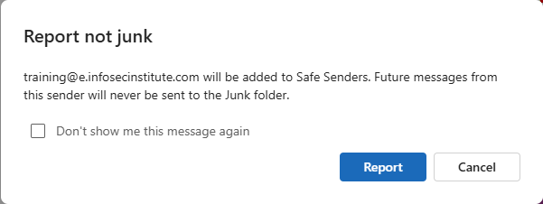
Outlook Web App

