FBM Standard Email Signatures

This document will help you in setting up and maintaining your email signature in Outlook. The two standard FBM email signatures look like the following (unless a different email signature format is provided to you in an email or a different document):

 | Your Name | Your.Email@myfbm.com  Your Title | Foundation Building Materials  2520 Red Hill Ave. Santa Ana, CA 92705  P: 555-555-5555 | M: 555-555-5555

 | Your Name | Your.Email@myfbm.com  Your Title | Foundation Building Materials  2520 Red Hill Ave. Santa Ana, CA 92705  P: 555-555-5555 | M: 555-555-5555

- The first thing you’ll need to do is copy either FBM email signature above. Highlight the full signature box above and right-click in the highlighted box to choose “Copy” (or hold down Ctrl + C on the keyboard to copy the highlighted section).

- Next, open Outlook (Classic) and go to the “File” tab in the top left of the Outlook window, then choose “Options”.
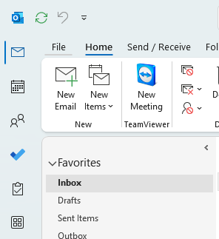

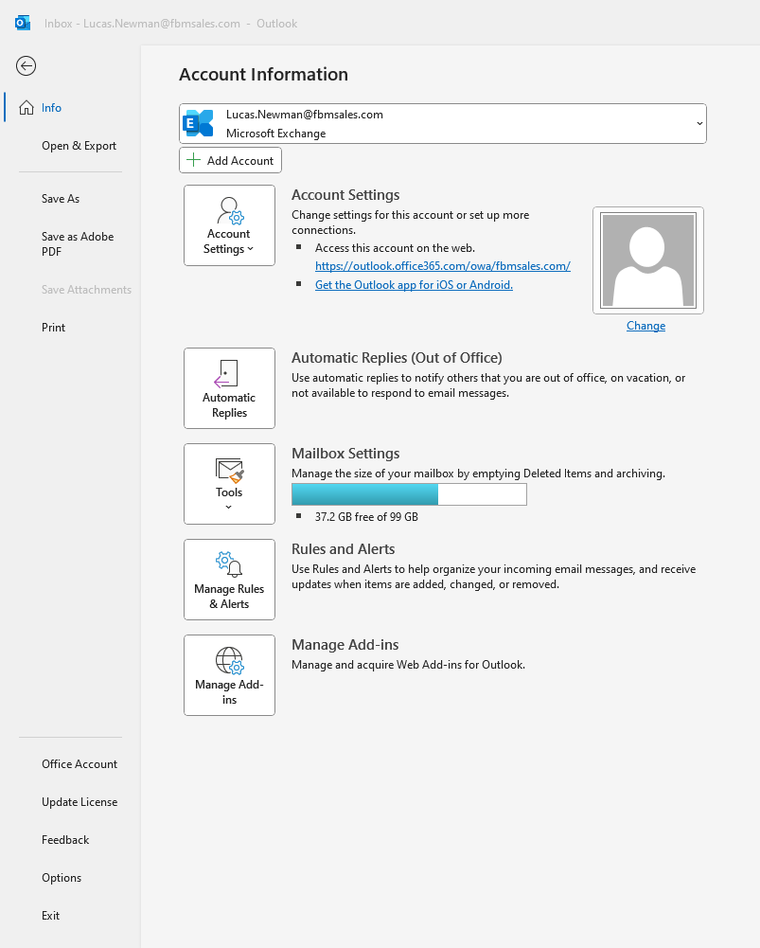

- Inside the “Options” menu you need to choose “Mail” in the left column, then choose the “Signatures…” block to the right.

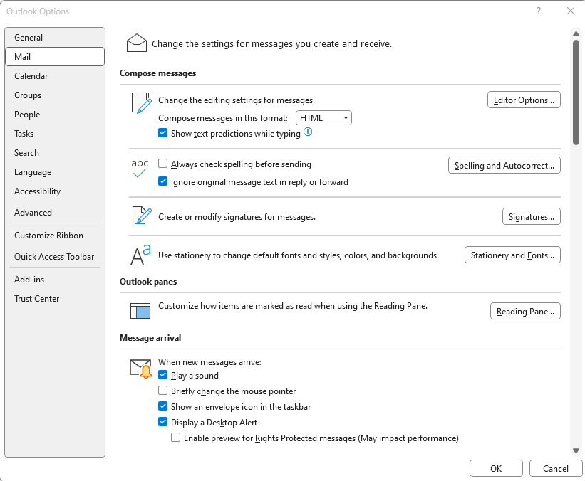

- Inside the Signatures and Stationery window, click on “New”. Enter a name for the signature then hit “OK”.

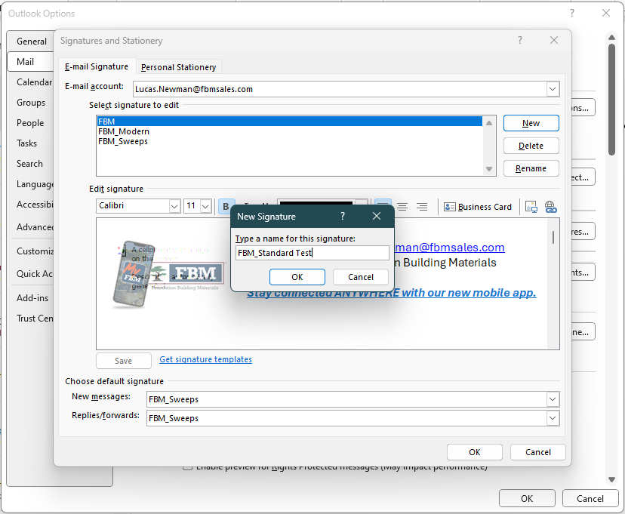

- Now that you have created a new signature name, you need to paste the copied signature from above into the open box below. Click in the open box to put the cursor in there, then you can right-click the mouse and choose “Paste” (or click in the box and hit Ctrl + V on your keyboard to paste).
Be sure to update all info to reflect your name, email address, location, position, and contact information, then click on “OK” below.

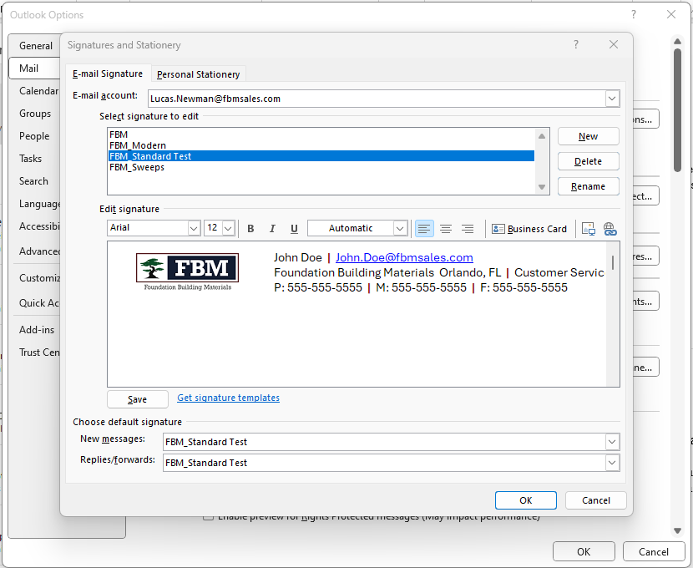

- Finally, don’t forget to add this signature to your “New messages” as well as “Replies/forwards”. Click on those boxes and choose the signature to set it correctly.

*** If you are using the NEW Outlook instead of Classic Outlook OR Webmail Outlook on an internet browser***

- Click the gear icon in the top right corner of the window
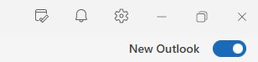

- In the Settings box that comes up, under Accounts, click on Signatures, then Click the blue button that says +New signature
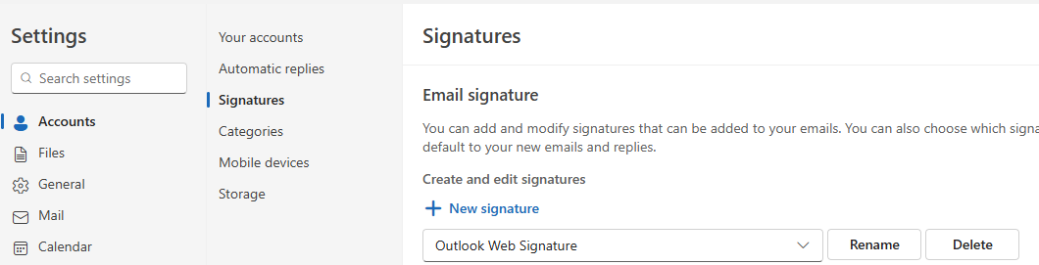

- Go back to the top of this document and copy either FBM email signature template. Highlight the full signature box above and right-click in the highlighted box to choose “Copy” (or hold down Ctrl + C on the keyboard to copy the highlighted section).

- Paste the copied signature from above into the open box below. Click in the open box to put the cursor in there, then you can right-click the mouse and choose “Paste” (or click in the box and hit Ctrl + V on your keyboard to paste). Be sure to update all info to reflect your name, email address, location, position, and contact information, and then name the signature, then click on “Save” below.
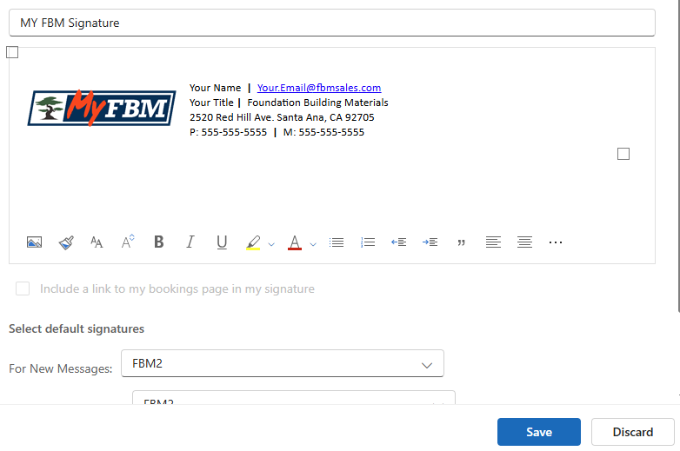
- After saving the Signature with your information, make sure you change the two drop downs that show “For New Messages” and “For Replies/Forwards” to the new signature that you just created and click Save.
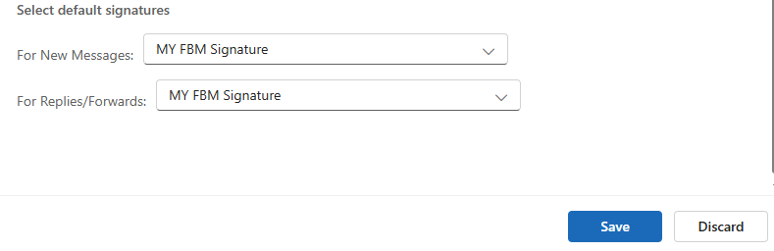

- After that you can exit out of the Settings box and test your new signature by starting a new email.

