Connecting to Global Protect

For all users who are not at a branch hard-wired into the FBM network or on FBM Employee Wifi, in order to connect to the internet and network, you will have to first connect to Global Protect.

To know if you are connected to Global Protect, click on the system tray arrow (^) at the bottom right of your task bar. There will then be a globe icon. If the globe is blue, like the below screenshot, you are successfully connected.

Here is what you will see if you are successfully connected while in an FBM office:

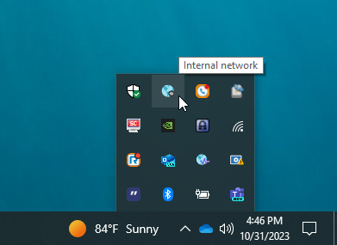

Here is what you will see if you are successfully connected working remotely:

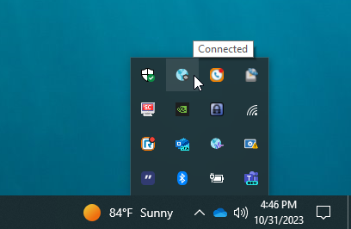
If you are disconnected from Global Protect, you will notice the globe icon is grey with a red circle, like the screenshot below:

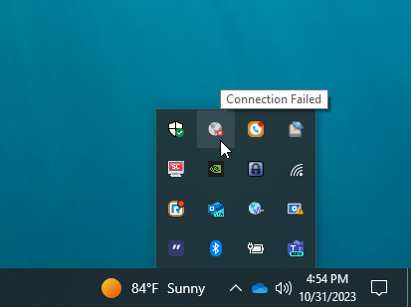

To reconnect, click on the grey globe icon and then click on Connect:

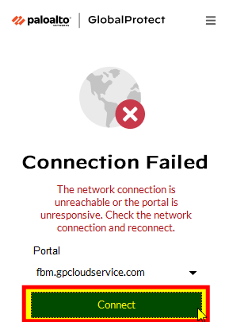

The other option would be to click on the 3 lines in the top right corner and then click Refresh Connection and choose Connect:

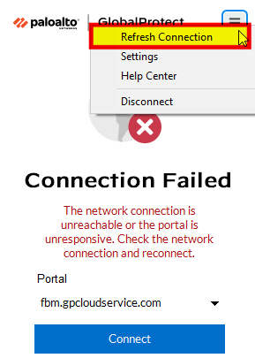

If you are unable to connect, the first step would be rebooting your computer or laptop and starting the process of connecting over. If you are still unable to connect to Global Protect reach out to FBM Support – supportcenter@myfbm.com.

